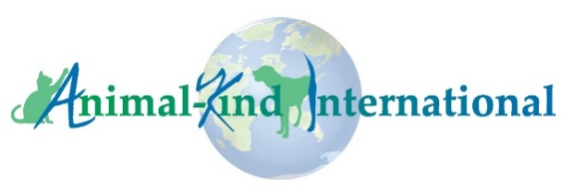
Animal-Kind International

Africa-Based Animal Welfare Organization Grant Program FAQs

Q: Who can apply for a grant?
Any organization that is based in Africa, has been operating for at least three years in the animal welfare sector in Africa, and whose main goal is to improve the lives of domestic animals in their community, is eligible to apply. They should be registered in their country of operation as an NGO, charity, non-profit or similar organization. Universities, churches, church groups, and 501(c)(3) organizations are not eligible.

Q: How can an organization apply?
Organizations interested in applying for an AKI grant should submit a complete grant application between May 22 and June 15, 2023 (midnight GMT deadline). We will not accept proposals submitted prior to May 22, 2023. To be considered eligible, all required documentation must be received by midnight GMT on June 15, 2023. AKI will only review complete submissions. Applications and supporting documentation received after the deadline will not be considered. We will send an email acknowledging receipt of all proposals. If you do not receive an acknowledgement within five days of submission of your application, you should notify AKI at the email address in the application.

Q: What types of projects do you fund?
To learn about the types of projects we are interested in, we strongly recommend that you review grant project descriptions and reports (AKI Blog posts) from previous years, all of which are available on the AKI website.
Q: What is the time-period of the grant activities? All grant projects must be completed within six months from receipt of grant funds.

Q: Do you accept photos and videos as part of a proposal application?
We accept photos only, but they should be specific to the proposed project, and they must be well-labelled and sent as jpeg email attachments. Photos are not a substitute for a well-conceived, written proposal and should be used only to support the written application.

Q: Do you fund projects in the U.S. Asia, or other regions?
We only consider grant applications for projects from Africa-based organizations, not from organizations based in countries outside of Africa.

Q: How much funding does AKI provide?
For previous grantees who have successfully completed their AKI-funded grant, the budget ceiling is US$3000. For those who have not received an AKI grant previously, the ceiling is US$2000. However, we have a limited budget for our grant program, and we want to award as many grants as possible, so please keep that in mind when developing your proposal and budget. Rather than automatically submitting a budget for the maximum amount, submit a cost-effective and impactful proposal --and then budget for that.

Q: Our organization previously received an AKI grant. When can we apply again?
Previous grantees are free to apply each year as long as they have successfully completed their previous grant activities and reporting in a timely fashion.

Q: How long does the grant review process take?
AKI’s proposal evaluation committee will review applications between June 15 and August 1, 2023. We will announce grant awards on/about August 1, 2023.

Q: How will grantees receive funds?
Once we notify you of the award, we will discuss with you the best method of transferring funds to your organization.

